**Input File:**

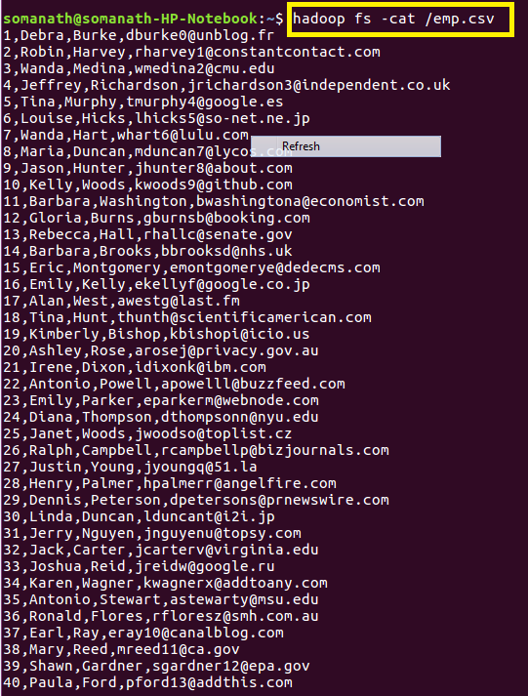

**load the data into Hbase:**

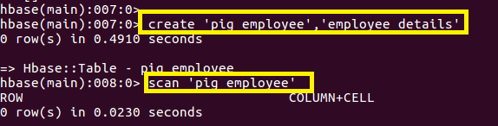

**Open pig grunt shell in Map reduce mode:**

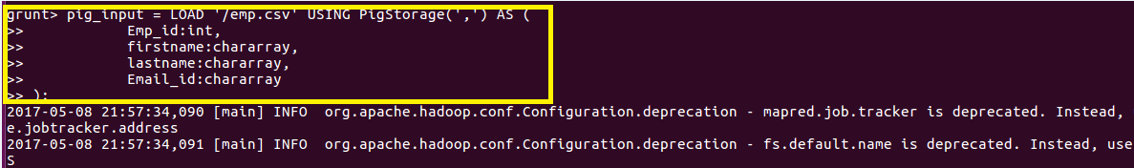

**Storing the data into Hbase:**

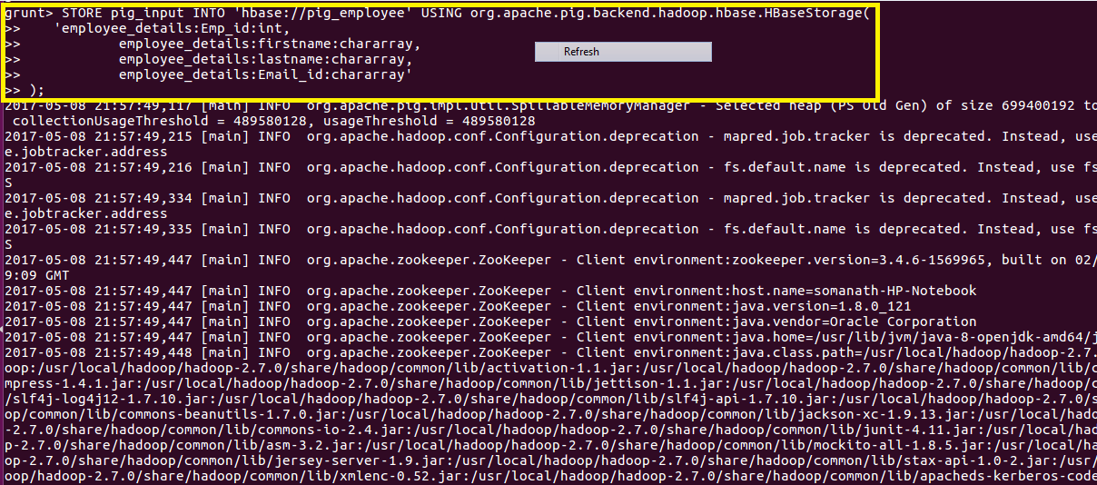

**File is successfully stored in Hbase as shown below:**

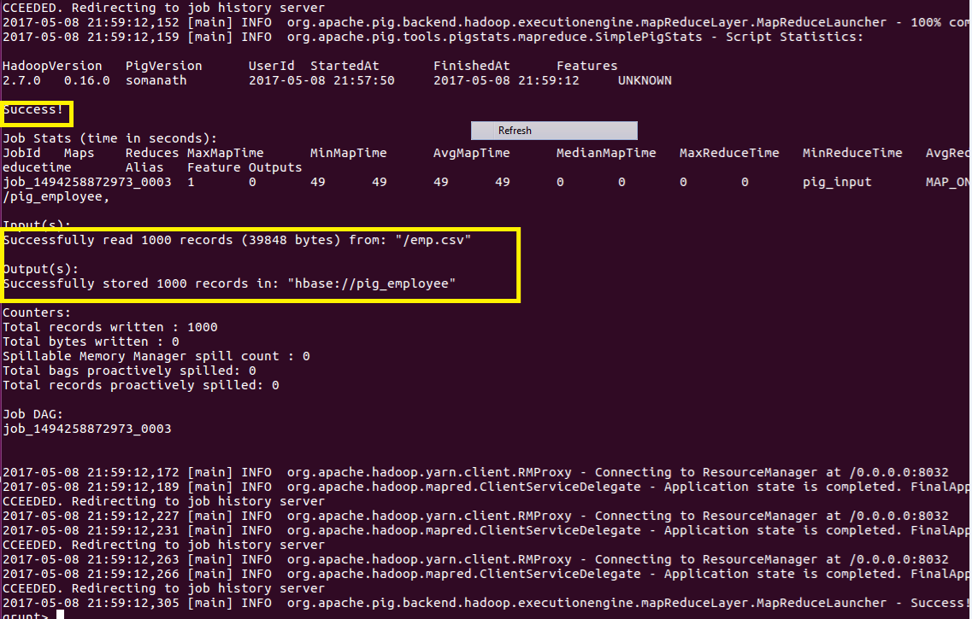

**Output Verification:**

